A1. Data Processing – Pandas, pandas_datareader

# Expected Output

Below is an example for testing. You are strongly encouraged to do more tests with different user inputs.

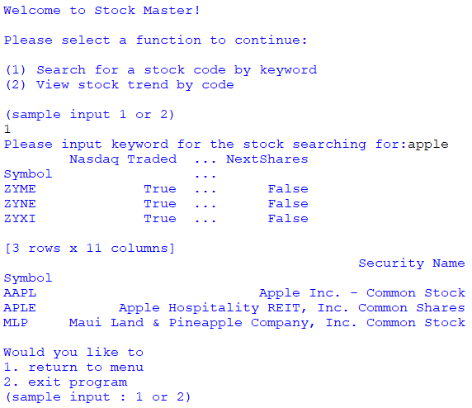

At this time, check the generated files:

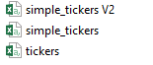

Open them to check according to sequence of tickers, simple_tickers, simple_tickers V2.

